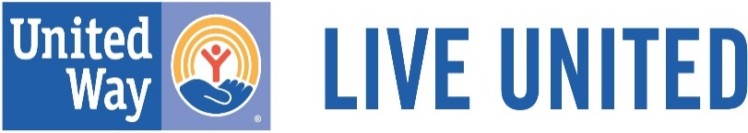
UNITED WAY OF INDIANA COUNTY
2023 SUMMER GRANT PROGRAM APPLICATION GUIDELINES
Mission Statement: It is the goal of the United Way Grant Program to help meet critical human service needs and improve the quality of life throughout Indiana County by inspiring and uniting its residents.

APPLICATION GUIDELINES

The United Way of Indiana County Grant Program Committee and the United Way of Indiana County Board of Directors administers a small grants program designed to award grants to qualifying entities that meet the general guidelines and present a fully developed proposal geared toward meeting the priority needs of Indiana County.

A United Way of Indiana County grant project is defined as one that addresses:
- Health
- Education
- Financial Stability
- Basic Needs

Funding Guidelines
- Only projects that relate to one of the priority needs listed above will be given consideration in the grant approval process.
- Funding is awarded for one year. Projects that have received grant funding from UWIC for two (2) years in a row must wait out one year before reapplying for funding for the same project.
- Eligible expenses include any personnel who will be delivering a component of the service, marketing materials, printing, program supplies, etc needed for the direct program staff to use in conducting or promoting an event.
- Purchases of equipment necessary for the direct provision of services of a United Way funded program may be an allowable expenditure, however, all proposed equipment purchases must be listed specifically in the agency funding proposal. Transportation costs for clients, or for direct service staff to a service site may also be considered. However, the Panel responsible for reviewing the proposals will determine the legitimacy of any such requests. Recommendation by the committee does not guarantee allowance by the Board of Directors.
- United Way funding may not be used for general operating expenses including but not limited to administrative salaries, mortgage or rent expenditures, capital building expenditures, general maintenance, utilities, insurance, national, state or local association dues, celebrations, endowments or operating deficits.
- Funds may not be used for projects already funded by the United Way of Indiana County through another allocation process.

WHO MAY APPLY

Grants will be awarded on a merit basis to those 501c3 entities and other organizations that demonstrate a solid programmatic plan for meeting an unmet human service need of the people of Indiana County and/or who qualify to receive charitable contributions as defined under Section 170 (c) of the Internal Revenue Code. Total amount awarded is subject to the amount designated by the United Way Board of Directors annually.

SUBMITTING AN APPLICATION

The application deadline is Friday, July 7th, 2023 by noon. Grants will be awarded by September 1. All grant funds must be spent within one year of allocation. The total amount and size of grants will be decided at the discretion of the United Way Grant Program Committee, but typically range between $500-$2500.

Only electronic applications will be accepted. Provide sufficient information to enable the Grant Program Committee to have a clear understanding of your project.

Limit one application per program.

A final report on the results of the project must be submitted to the United Way office within 30 days of the end of the program or project, demonstrating that the funds were utilized for their intended purpose. This report is to be submitted on the United Way Grant Project Final Report Form.

Any questions may be addressed to Angela Jackson, Executive Director, uwjackson@uwindianacounty.org

Please email the application to: uwhainaut@uwindianacounty.org

